Student Guide – APT Project Definition

# Topic: Managing Custom Menus and Tables in Restaurants

# PART I

## 1. PERSONAL BACKGROUND

|  |  |
| --- | --- |
| Student name | Rodrigo Perez |
| RUT | 19.925.199-6 |
| Career | Computer Engineering |
| Headquarters | Maipú |

## 

|  |  |
| --- | --- |
| Student name | Camilo Alchao |
| RUT | 20.975.806-7 |
| Career | Computer Engineering |
| Headquarters | Maipú |

## 

## 2. APT Project Description

## Project Name: Personalized Menu and Table Management System for Restaurants

## Area(s) of Work: Software development, technological process management, service innovation

## Competencies:

## - Design and development of IT solutions

## - Requirements analysis

## - Information systems implementation

## - Technology project management

## 3. APT Project Rationale

# Relevance of the APT Project: The project seeks to address the needs of restaurants in the Metropolitan Region of Chile... optimizing service and resources.

# APT Project Description: This consists of the development of a web application with menu, inventory, table, order, and administrative panel functionality.

# Relevance of the project to the graduate profile: It is linked to skills in programming, project management, and process analysis.

# Relevance to professional interests: It allows for practical experience in technological solutions applied to the service industry.

# Development Feasibility: Feasible in one semester with a functional prototype, using available web frameworks and tools.

# PART II

## 4. Objectives

## General Objective: Develop a software system for managing personalized menus and controlling table service in restaurants, with the goal of optimizing customer service and improving operational efficiency.

## Specific Objectives:

## 1. Design and implement a web interface.

## 2. Develop an inventory module.

## 3. Implement table service control.

## 4. Create an administration panel.

## 5. Validate the prototype with simulated users.

## 5. Methodology

## The project will be developed using an agile methodology (Scrum), in stages of requirements, mockup design, incremental development, testing, and final delivery.

## 6. Evidence

|  |  |  |  |
| --- | --- | --- | --- |
| Type | Name | Description | justification |
| advance | Functional mockup | System visual design | Allows validation before development |
| advance | partial report | Document with progress | Evidence of the process |
| Final | Functional prototype | Web application with key functionalities | Main evidence of the project |
| Final | Final report | Document with analysis and results | Consolidates learning |

## 7. Work Plan

|  |  |  |  |  |  |  |
| --- | --- | --- | --- | --- | --- | --- |
| competence | Activity | Description | Resources | Duration | Responsible | Remarks |
| Software development | Requirements gathering | Identify key functions | PC, internet | 1 week | student | Mock interviews |
| Interface design | Mockup | Screen design | Figma, PC | 2 week | student | User validation |
| Programming | Front-end | Web interface construction | PC, frameworks | 4 week | student | Use HTML/CSS/JS |
| Programming | Back-end | Logical implementation and database | PC, local server | 4 week | student | Use Node.js/Django |
| Project management | Evidence | System validation | PC, prototipe | 2 week | student | Feedback iterations |
| Communication | Final report | formal document | PC, Word | 2 week | student | formal delivery |

**Detailed requirements**

|  |  |  |  |  |
| --- | --- | --- | --- | --- |
| **ID** | **Type** | **Description** | **Priority** | **Acceptance criteria** |
| RF-01 | Functional | The system must include a user management module with differentiated roles (customer/waiter/administrator). | High | Users are created and their roles are correctly assigned. |
| RF-02 | Functional | The system must allow the visualization of an interactive restaurant map showing the status of each table. | High | The user can see available/occupied tables on the map. |
| RF-03 | Functional | The system must allow the selection of a table from the map to make a reservation. | High | Reservation confirmed when selecting a free table. |
| RF-04 | Functional | The system must store table information (number, capacity, status) in a database. | Medium | Tables can be managed from the system. |
| RF-05 | Functional | The system must record and keep the database of ingredients and products up to date. | High | Ingredients/products are registered and can be queried. |
| RF-06 | Functional | The system must display the availability of dishes in real time based on ingredient stock. | High | If an ingredient is missing, the dish appears as “unavailable.” |
| RF-07 | Functional | The system must have an intuitive and user-friendly graphical interface. | Medium | Users perform basic tasks without prior training. |
| RF-08 | Functional | The system must allow the registration and management of project reports and statements. | Low | Reports are generated in PDF or Excel format. |
| RNF-01 | No Functional | The system must be accessible from web and mobile devices with a responsive design. | High | It is tested on PC, tablet, and smartphone with correct functionality. |
| RNF-02 | No Functional | The system must ensure that information is available with 99.9% uptime. | High | **Monthly availability report ≥ 99.9%.** |
| RNF-03 | No Functional | The system must respond in less than 2 seconds per operation under normal conditions. | Medium | **Load testing demonstrates times ≤ 2 seconds.** |
| RNF-04 | No Functional | The system must implement security standards to protect user information. | High | Passwords are encrypted and connections are verified. |

## 8. Gantt Chart

The Gantt Chart will be organized over 18 weeks, dividing activities into Phase 1 (planning), Phase 2 (development), and Phase 3 (testing and reporting).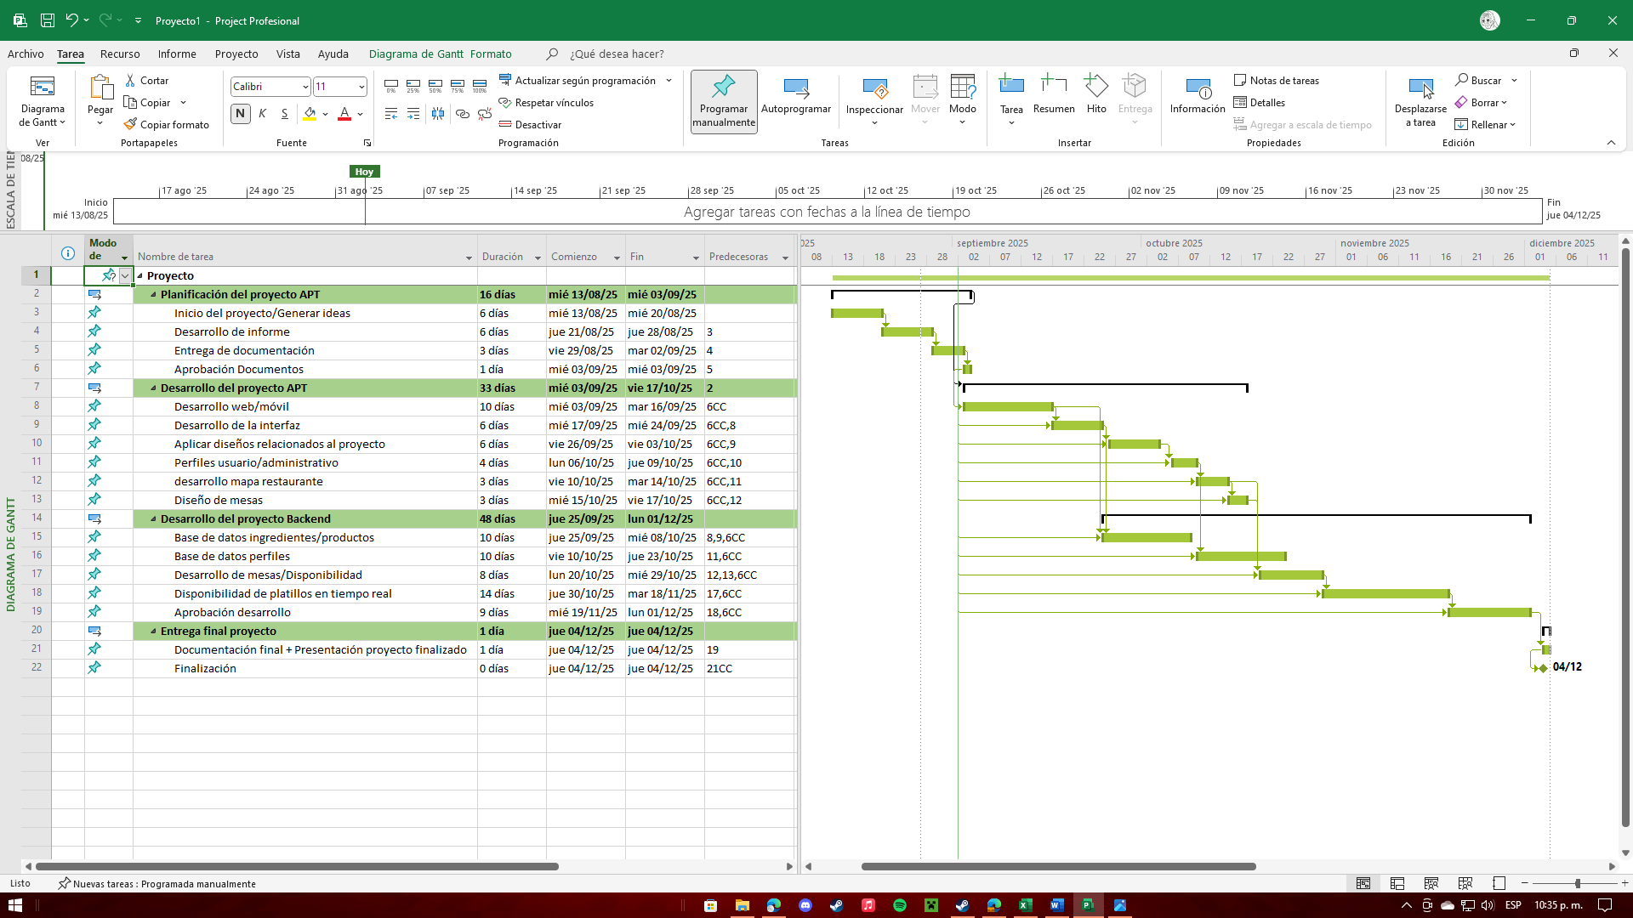

List of requirements – grouped by phases

**PHASE 1 – Planning**

• 1 APT Project Planning

● 1.1 Project Initiation/Generation of Ideas

● 1.2 Report Development

● 1.3 Documentation Submission

● 1.4 Document Approval

**PHASE 2 – Frontend Development**

● 2 APT Project Development

● 2.1 Web/Mobile Development

● 2.2 Interface Development

● 2.3 Applying Project-Related Designs

● 2.4 User/Administrative Profiles

● 2.5 Restaurant Map Development

● 2.6 Table Design

**PHASE 3 – Backend Development**

● 3 Backend Project Development

● 3.1 Ingredient/Product Database

● 3.2 Profile Database

● 3.3 Table Development/Availability

● 3.4 Real-Time Dish Availability

● 3.5 Development Approval

**PHASE 4 – Delivery of report and producto**

● 4 Final project delivery

● 4.1 Final documentation + Presentation of the completed project

● 4.2 Completion